BI1I – PROBLEM SET 03 (90 pts)
Winter Term 2026
Released: Feb 20, 2026
Due: Feb 25, 2026 (midnight)

These questions are meant to sharpen your understanding of the content discussed in class. We hope these questions are engaging enough to encourage collaboration and discussion with your fellow classmates; however, you are each expected to submit individual answer sheets, written in your own words. Please cite any outside sources that you use – at times, these questions walk through specific examples that are outside the scope of the lecture slides, so we expect you to consult textbooks and/or published works/reviews. As described in the course policies, you can NOT use ChatGPT or other AI platforms to write your answers, zero tolerance.

Problem 1: Grasping the TCR-calcium-NFAT signaling pathway through a series of experiments (58 pts)

a. We have discussed the importance of different cytokines and transcription factors in class, particularly how influence immune cells in response to environmental and intracellular changes. Explain what cytokines are, where they act/what they act on, and how they influence cellular function; contrast this with what transcription factors (TFs) are, where they act/what they act on, and how TFs influence cellular function. 6 pts

Cytokines are small proteins that deliver messages from one cell to another, on a high level at least. Specifically, they bind to receptors on target cells which subsequently trigger some response that can result in something such as gene expression or some change in cells (i.e. proliferation). TFs act directly on DNA by binding to specific sequences in the nucleus to activate or repress transcription of specific genes. Basically cytokines act between cells and TFs act within a cell.

Immune cells are influenced by a wide range of transcription factors (TFs), including NFkB members, STATs, AP1 factors, IRFs, NFAT members, etc. We have discussed NFkB signaling in class, so let’s practice taking a closer look at a different TF: NFATs (full name is Nuclear Factor of Activated T cells and includes NFAT1-4, T cells specifically express NFAT 1, NFAT 2 and NFAT 4)
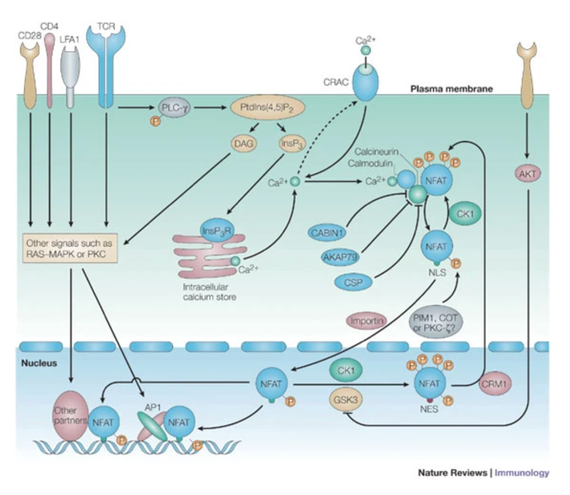
NFAT family members are particularly important to alter gene expression in response to elevation in cytoplasmic free Ca²⁺. Many cell types use Ca²⁺ fluxes as “second messengers” between signaling receptors and the nucleus. One well-studied and fascinating pathway involves TCR signaling.
A detailed diagram is included (right), outlining the pathway from TCR signaling to NFAT activation. TCR signaling causes activation of a protein called phospholipase C-γ (PLC-γ), which activates other proteins that ultimately cause the release of Ca2+ ions that were originally stored in the endoplasmic reticulum (ER). This increase in cytoplasmic Ca2+ is sensed by ion channels that live in the cell surface membrane, activating these “calcium-released-activated” calcium channels to continue maintaining higher levels of intracellular calcium.
We will explore how the subsequent steps lead to NFAT activation through some experimental data. Picture yourself in the 1990’s….
Beals et al. studied how NFAT can communicate signals from the cytoplasm to the nucleus in a Ca²⁺ dependent way. They started by knowing a few key facts:
- NFAT’s structure, shown below in (A), contains different domains - NLS: nuclear localization sequence; SRR, Serine rich region; SP’s: Serine-Proline repeat regions; RSD, DNA binding domain
- Treatment with ionomycin, a Ca²⁺ ionophore, allows high levels of Ca²⁺ to flow into cells, even in the absence of physiological signaling, and activates T cell response genes like Il2
- NFAT is critical for this response
- The drugs cyclosporin A (CSA) and FK506 block this response to Ca²⁺ by inhibiting a Ca²⁺ dependent phosphatase, Calcineurin
- Calcineurin removes phosphates from proteins when it is activated by Ca²⁺
To understand how NFAT (the version called NFATc) conveys signals to the genome, the authors constructed versions of NFATc with a small “tag” of added sequence that could be detected with fluorescent antibodies (a “FLAG” epitope) and forced them to be expressed in cells whose responses could be followed by imaging. On staining with anti-FLAG fluorescent antibodies, they could visualize NFAT in the cell. Epitope tagging is a commonly used technique, which in this case was useful for distinguishing the experimentally manipulated NFAT (and its controls) from any other NFAT that might be in the cell.

The authors first asked how long it takes for NFAT to move from the cytoplasm to the nucleus after being exposed to Ca2+ conditions.

To answer this question, they took cells transfected with the NFATc-FLAG construct described above and treated them with ionomycin for various lengths of time. They then stained the cells with anti-FLAG fluorescent antibodies and imaged the cells with fluorescent microscopy to see how many cells contained nuclearized NFAT (NFAT that was in the nucleus rather than cytoplasm). The results of this time course are shown below (B) where the exposure times to ionomycin (x axis of scatter plot) are compared to the percent of cells that contained nuclearized NFAT (y axis of scatter plot).

a. How did NFAT respond to the artificial elevation of Ca²⁺? Approximately how long did it take for this response to be half-maximal? 4 pts

The elevation of Ca²⁺ d caused NFAT to rapidly accumulate in the nucleus. The half-max response is around 5 minutes.

The bar plot on the right above (B) shows the percent of cells that contained nuclear NFAT under conditions where the cells were exposed to ionomycin in addition to either FK506 or EGTA, which is a calcium “chelator” (meaning that it blocks free calcium ions from binding to other targets) for 60 mins.

b. How did the drug FK506 affect the ability of NFAT to enter the nucleus? How about EGTA? These results imply that the ability of NFAT to enter the nucleus depends on what factors? 8 pts

The authors were next curious about what exact part of NFAT controls movement in the cell.

Thinking back to the NFAT structure (fully shown in A), NFAT has a DNA binding domain (RSD= “Rel Similarity Domain”) as well as other sequences that do not bind to DNA but mediate other interactions. To test whether the RSD domain was specifically important for nuclearization, they fused the fluorescent protein GFP directly to the first 418 amino acids of the protein and asked whether this form of NFAT (referred to as CΔ418-GFP) could also nuclearize (CΔ418-GFP cartoon shown in C below, which is an altered version of the full form shown in A).

The authors visualized cells with fluorescent microscopy, which could detect CΔ418-GFP, comparing cells that had no calcium stimulation (NS, left image) to cells that were treated with ionomycin (I+Ca⁺⁺, right image). The results are shown in (C) below.

c. Do any samples show NFAT nuclearization? If so, describe which sample and what about the images leads you to this conclusion. What do these result reveal about the parts of NFAT that are needed for NFAT to move in the presence of high Ca²⁺? 5 pts

The authors next compared how NFAT (CΔ418-GFP) and normal NFAT behaved in the presence of FK506. Cells were treated with ionomycin for 1 hr and then exposed to FK506 for different lengths of time. The results shown below in (D) compare the percentage of cells containing cytoplasmic NFAT was measured (y axis) to the time of exposure to FK506 where NFAT (CΔ418-GFP) behavior is marked by open circles, while normal NFAT behavior is marked by open squares.

d. Referring to panel D, what is the effect of adding FK506 after the protein has responded to Ca²⁺? What does this tell you about the fate of the NFAT protein in a transient signaling response? 5 pts

The authors next wanted to identify the precise regions of the NFAT protein that were specifically responsible for its subcellular localization. They focused on the Serine-rich regions and tested the effect of mutating all, or many, of the Serines to Alanines in the SRR, to make mutant SRR:

The figure below shows the localization of wildtype (normal, WT) vs. mSRR NFAT (with the mutant SRR), or another mutant of NFAT with SerAla in the first SP region (mSP1). Note that these three samples are unstimulated. The fourth panel shows the effect of the mSRR mutant in the presence of FK506.

e. What have the mSRR and mSP1 mutations done to NFAT? Based on the results above, would you expect these mutated versions of NFAT to still be responsive to changes in Ca²⁺ levels, as native WT NFAT is? Why or why not? 4 pts

f. Based on your answer in e, what would you say is the part of NFAT that is important for controlling NFAT movement into the nucleus? In other words: based on the experimental results thus far, what keeps NFAT it in the cytoplasm? What moves NFAT to the nucleus? Please explain your thought process. 6 pts

To really put the nail in the coffin, the authors finally wanted to test whether the parts of NFAT that are important for controlling its movement are indeed the targets of Calcineurin action. Recall that Calcineurin is a Ca²⁺ dependent phosphatase – that is, it removes phosphates when it’s activated.

The researchers prepared truncated parts of NFAT that include the SRR domain and determined that these sections could be labeled with radioactive phosphorus by incubation with kinases (which add phosphate groups) in Brain Extract (they didn’t know exactly which kinases were needed). In the figure below, the top row indicates presence of radioactive phosphorus while the bottom row indicates presence of NFAT protein by NFAT staining (though the amounts loaded, in this real experiment, were evidently not equal).

Lane 4 (middle) shows that the wildtype version of NFAT found in brain extract is efficiently labeled by the kinases. Comparing this lane to lane 3 shows that the radioactivity labeling depended on adding the brain extract.

First, let’s focus on the top row in lanes 1 and 2: the researchers measured radioactive labeling in samples that had the mutant form of NFAT with all the Serines converted to Alanines.

g. What do these lanes reveal about the significance of the mutated Serines? Please explain your interpretation of the experimental results. 4 pts

Now let’s look at lanes 5, 6, and 7: for these lanes, the researchers incubated brain extract samples with the same kinases used for radioactive labeling as described in the other lanes 1-4. However, after this incubation, samples were washed and further incubated in a different solution containing either the highly specific phosphatase, Calcineurin, or one of two less specific phosphatases, PP1 and alkaline phosphatase. The subsequent radioactive labeling of NFAT was measured in row 1, as in the previous questions.

h. What do these results reveal about how Calcineurin acts on NFAT? Why were the other two phosphatases tested as well? Please explain your interpretation of the experimental results. 4 pts

i. The reviewers of this paper failed to note that the authors forgot to include the recipe for “calcineurin buffer” in the methods of this paper, although they had published on this before. Do you think the buffer used in the calcineurin reaction described in this figure contained Ca²⁺ or not? 2 pts

j. Putting together the results discussed in parts f, g and h, how do these findings answer the author’s intended question about whether Calcineurin targets the parts of NFAT that are important for controlling movement? In summary, relate these findings to a model of how NFAT activity is controlled by Ca²⁺. 6 pts

k. How does this signaling pathway compare to the NF-kB pathway discussed in class? Make sure to also describe how NF-kB is able to gain entry into the nucleus in your answer. 4 pts

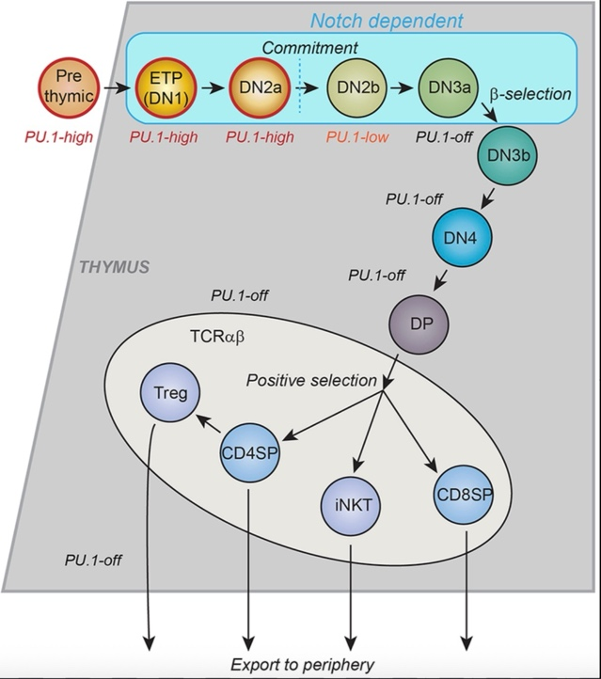
Problem 2. CD4 vs CD8 fate (32 pts)
T-cell development is divided into numerous stages, as discussed in class. The following schematics summarize these stages of development.
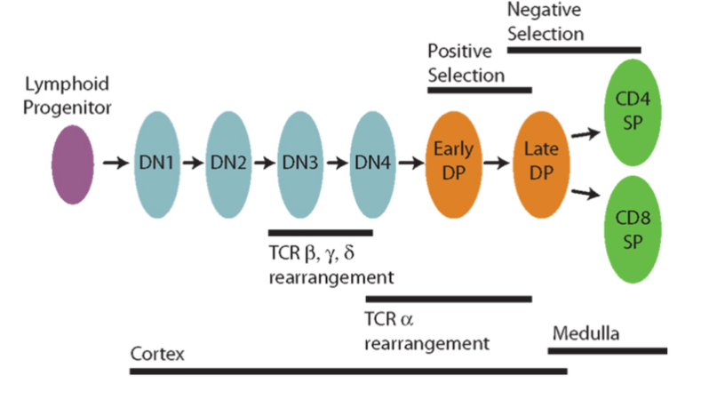

Interestingly, as T cells become either CD4+ or CD8+ after the DP stage, there seems to be a bias towards cells restricted to MHC class I (CD4+) versus class II (CD8+). Even though, in an effector response, the number of CD4+ and CD8+ T cells is comparable, the number of CD4+ vs. CD8+ T cells in the thymus is skewed. This phenomenon has interested current researchers, so we will walk through some of the ways people are currently quantifying and deciphering the mechanisms/sources of asymmetry in the thymus.

a. Based on your understanding of the transcription factors involved in CD4 vs CD8 fate, explain why T cells must “choose” either the CD4 or CD8 pathway. 4 pt

b. Why does the immune system benefit from having both CD4+ and CD8+ T cells exist? 5 pt

The DP stage of development can be divided into 3 main parts: DP1, DP2, and DP3. DP1 thymocytes are TCR^{lo}CD5^{lo} and constitute pre-selection thymocytes; DP2 thymocytes are TCR^{int}CD5^{hi} and consist of class I- and class II-restricted thymocytes in the first 12-48 h of development; and DP3 thymocytes are TCR^{hi}CD5^{int} and consist entirely of CD8 lineage cells developing ∼60 h after onset of selection. Here:
- lo = low expression,
- int = intermediate expression,
- hi = high expression
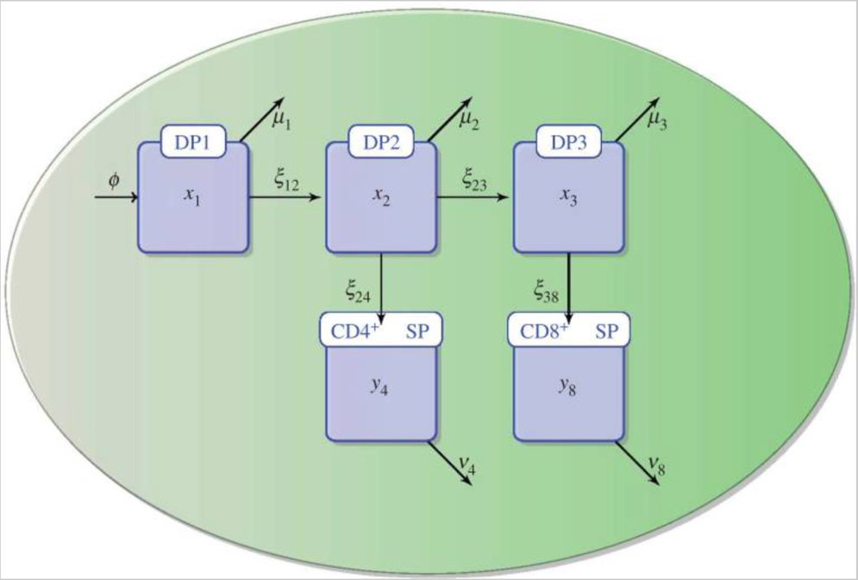
DP1 thymocytes are generated from CD4 CD8 double-negative (DN) thymocyte precursors at a constant rate 𝜙 (total cells per day). Cells in each DP population either develop to the next stage(s) or die. v₄ and v₈ are combined death and egress rates from SP populations. An ordinary differential equation model was generated to characterize the progression of immature thymocytes through five transient stages of development: DP1 (x₁), DP2 (x₂), DP3 (x₃), CD4 SP (y₄), and CD8 SP (y₈). Additionally, μ denotes the death rate, while ξ denotes the maturation rate. This is elegantly shown in the flow chart below:

At least two different hypotheses can explain the previously mentioned thymic origin of the bias (between the numbers of CD4+ vs CD8+ cells):
1. At the DP1 stage, there is an asymmetry in the number of DP thymocytes with a TCR that can bind to MHC class I versus MHC class II, or
2. During the DP or SP stage, there exists some asymmetry in either maturation or loss processes (migration to the periphery or death).

Three sets of experiments are carried out to identify the source of the CD4/CD8 bias:
- The first (or control) experimental assay arrests thymic maturation at the DP stage to then switch it on, and thus, T-cell development can be followed during 10 days in a synchronized way. Cell numbers were analysed at days 0, 1, 2, 3, 4, 5, 6, 7, 8, 9, and 10.
- The second experimental assay is exactly as the first, but with MHC class-I-deficient mice, so that only CD4⁺ T cells can be selected.
- Finally, the third experimental assay is performed, with MHC class-II-deficient mice, so that only CD8⁺ T cells can be selected. In this way, the authors can simultaneously and independently study the development of CD4⁺ and CD8⁺ T cells.

c. Based on the aforementioned experiment designs, what experimental technique would you use for the analysis of cell numbers? 1pt

d. How would you differentiate between the DP1 and DP2 stages? 2pt

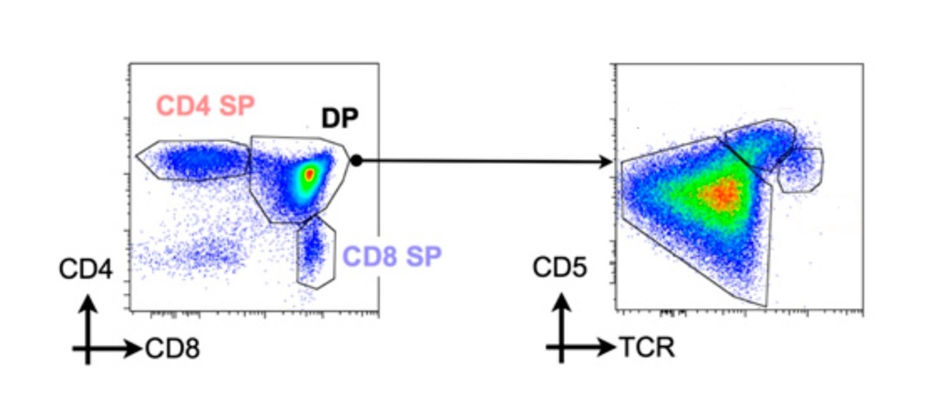
e. Based on the above definitions and your answer to the previous question, label the three shapes (shown on the plot on the right) as either DP1, DP2, or DP3. 3 pt

f. Why are deficient mice used in this experiment? What is the purpose of doing so? 2 pt

Given the experimental data and the mathematical model, the authors obtained estimates for the parameters of the model. The most striking differences appeared in the DP2 compartment. For example, for the control experiments, they estimated the maturation rate, ξ₂₄ = 0.14 per day and ξ₂₃ = 0.07 per day, whereas for the MHC class-I-deficient case, the death rate per day and per day, and for the MHC class-II-deficient case per day and . This indicated that a source of asymmetry is the difference in death for the CD4+ and CD8+ thymocytes at the DP2 stage. It is at the DP stage when the commitment to either CD4+ or CD8+ lineage is decided. Furthermore, they introduced the dimensionless parameter s, or selection efficiency, for any of the DP compartments as the ratio between the maturation rate and the sum of the maturation and death rates.

g. Why do the authors make estimates for the death rates and the maturation rates? 5 pts

h. For DP2 thymocytes in the case of MHC class-I-deficient T-cell development, write an expression for selection efficiency, s₄, and calculate the numerical value for the selection efficiency based on the data given above. 2 pt

In the case of MHC class-II-deficient T-cell development, the selection efficiency is given by:
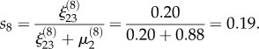
where μ denotes the death rate, while ξ denotes the maturation rate.
i. Based on your calculated selection efficiency for MHC class-I-deficient T-cell development and the given selection efficiency for MHC class-II-deficient T-cell development, what conclusion can you draw regarding the relative efficiencies? 3 pt

The researchers found that at the DP1 stage, no significant differences are observed between the death μ₁ and maturation rates ξ₁₂ estimated for the three different experimental conditions: control, MHC class-I- and MHC class-II-deficient mice.

j. Based on these experimental observations and parameter estimates for MHC-deficient mice, what can the authors identify regarding the source of CD4 enrichment? What stage of T-cell development do they believe it occurs at? 2 pt

k. What hypothesis (of the two) does the data and quantification support? 3 pt

Bonus Question – The following is NOT a graded problem but will be helpful in preparing you for the FINAL EXAM. We encourage you to read through the questions to check if there are any gaps in your understanding.

These concepts are critical for the more complex ideas we are getting to in class (and that you will probably encounter in any immunology-facing research). Please feel welcome to come to office hours or shoot an email to the TA’s if you have questions about the content!!

- We have talked a lot about BCRs so far (aka membrane-bound immunoglobulins, aka antibodies). But what about the TCR? Describe at least 3 differences between the receptors used by B cells and the receptors used by T cells to recognize antigen (TCR vs. BCR; structural differences, binding target differences, diversity/modification strategies, etc.) 6 pts

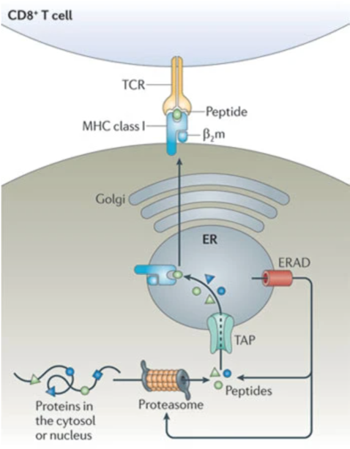
Antigen presentation is a critical concept that 1) highlights how the innate and adaptive immune systems interact and 2) distinguishes T cells and B cells. Recall that T cells only recognize antigen that are loaded on an MHC molecule (either MHC class I or MHC class II) while B cells detect antigen without such “antigen presentation.”

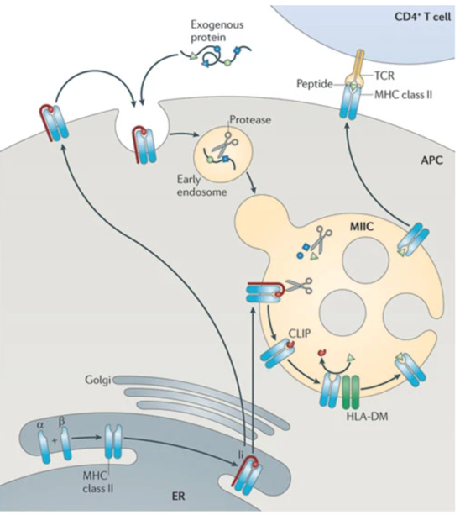

Interestingly, it turns out that MHC class I and MHC class II load antigen via different mechanisms (shown above). The left diagram shows how MHC class I molecules live in the endoplasmic reticulum (ER), where they bind antigens that are in the ER after cytosolic proteins have been degraded (by cellular machinery – the proteasome) and the subsequent peptides (antigens) are delivered into the ER through a transmembrane protein (TAP). Alternatively, the right diagram shows how MHC class II molecules live in vesicles within the cell; when the cell engulfs extracellular material, the engulfed material is encased in its own vesicle which can then fuse with the MHC class II-containing vesicle. The MHC class II-containing vesicle contains enzymes that can degrade extracellular protein, and this can result in the loading of the MHC class II with antigen derived from the engulfed material.
TLDR: MHC class I is loaded with antigen derived from proteins that existed in the cytoplasm of the cell, while MHC class II is loaded with antigen derived from proteins that existed outside of the cell.

b. What cell types express MHC class I? How about MHC class II? 2 pts

c. Which T cells recognize antigen presented on MHC class I and what is their primary function? How about the T cells that recognize antigen presented on MHC class II and their primary function? 4 pts

d. Considering your answers to part c and d, why might the different processing pathways for MHC class I and MHC class II be advantageous? (What sorts of immunological threats are “easier” to pick up by MHC class I vs class II? Does the subsequent recruitment of CD4 or CD8 T cell make sense as a response? Feel free to use a logic table or diagrams) Please explain your thought process. 6 pts

e. Let’s connect this back to BCRs: BCRs recognize specific epitopes on antigens that are still fully folded and have not been degraded by the cell, while TCRs recognize specific epitopes after some processing steps to have it loaded on an MHC molecule. Recall how proteins fold and can form complex structures; are the types of epitopes recognized by BCRs different from the types of epitopes that TCRs might recognize? (terminology: “epitope” refers to the specific region on the antigen that is actually recognized and bound by the BCR or TCR, “antigen” refers to the entire protein that is being recognized). 4 pts

